STAFF BULLETIN


Week Commencing 15 November 2010

HEAD’S FOCUS FOR THE WEEK: To have a big push with Y10 and Year 11 uniform, tutors to ensure daily uniform checks are done and that appropriate action is taken when required.

Assemblies: Form Tutors E
VI Form Assembly: Form Tutors B

SLT to meet daily at 8.30 am

Collective Act of Worship: Human Rights

All classroom bookings to be made through Mrs L Donald
All other room bookings to be made through Mrs H Frost

Mon 15/11/2010 Last date November GCSE exams

Spot the star competition entry forms available to purchase at 50p from Learning Resources Centre along with copper coins

Mrs T Hampton and Mrs S Jones on course all day

8.30-4.00pm 10TL - BTEC Travel and Tourism students to attend trip to National Maritime Museum – accompanied by Miss N Cope
Students on trip: Jes Brown, Luke Dennis, Hannah Lennon, Calum Olley, Ben Paris, Sam Pinner and Chantelle Taylor

8.30am-3.30pm The following students to attend Basildon District Youth Conference at Wat Tyler Park - Lauren Casey, Charlotte Church, William Dear, Siobhan Dunne, Daniel Frost, Cameron Hogwood, Hollie Howe, Louise Jones, Sophie Lambert, Lotte Major, Chloe Matthews, Jordan Orton,
Ellen Seaman, Shelly Sydes, Charlotte Taylor accompanied by Mr T Moss and Mrs S Wilson

Pd 2 Leslie Williams to see Year 12 in B & E Conference room

Pd 2 General Studies - B&E Conference Room – Miss K McEwan

11.30am-12.10pm Strategic ICT Meeting – Mr N Sydenham and Mr C Furniss

Pd 4 General Studies - B&E Conference Room – Miss K McEwan

1.00pm Mr S Clayton at School Engagement meeting at South Essex College

3.00pm NQT/GTP Meeting – led by Miss K Evans on SEN and GTA

3.00-4.00pm Kayzar Dance Club - Gym

3.00-4.00pm Yr 7-9 Chelsea Football Coaching

3.00-4.00pm BTEC Performing Art Course – Mrs N Watts – Drama 1

3.00-9.00pm Trampolining course for PE staff – Sports Hall – All PE staff involved

4.00pm Mr R Hodges to meet with Chair and Vice Chair

5.0-7.0pm Family Fun with Computers – PC4

6.00pm Curriculum Committee meeting

Tue 16/11/2010 Mr R Hellen, Mr P Mower and Mr R Newsham at Leadership Pathways Core day 2

8.45-10.00am Mr R Hodges to attend SSCO meeting at William de Ferrers School

Mrs E Long on course all day

Pd 1 and Pd 4 Self-defence teacher Steve Merrett in school

9.00-10.00am ECM meeting with Mr A Draycott, Mr D Windeatt and Miss K Evans

10.00-11.30am Cards, Calendars and Christmas Shopping course – Janet Griffiths – B&E Conference room

11.30am-12.10pm ELearning Resources Meeting – Mr N Sydenham and
Mr A Jacobs

Pd 3 Ms I Eleftheriou to observe Mrs S Jones

Pd 5 General Studies - B&E Conference Room – Miss G Theobald

Pd 5 Miss K McEwan to meet Dave Harrison, Mr Harrison and Mrs Morris

2.45-3.45pm BTEC Horse Care – Miss H O’Rourke – B4

2.45pm BTEC Fish Husbandry - DT2

3.00-9pm Trampolining Course – Sports Hall – All PE staff involved

3.00-4.00pm Yr 7&8 Netball practice – Miss M Osborn

3.00pm Church representative group meeting – Admin meeting room

3.00-4.30 Environment Club – Ms A Sampson – Lab 6

6.00-7.30pm A Brief Introduction to Psychology community course

6.00-7.30pm Microsoft Publisher course – Mr M Oakshott – PC2

6.00pm Parents evening for students going on Ski trip in February – West Hall

Wed 17/11/2010 Yr 8-11 Interim reports Subject Leader/HOY deadline

Miss S Cardy on course all day

Students – Daniel McElvenny and Eloise Willis attending Melbourne Athletics for Volleyball Leaders course run by WDF SSP – all day

Yr 11 Alternative Education students to attend GOALS project in Southend all day

8.30am Staff briefing – B&E Conference Room

9 am Miss K McEwan, Mr M Harper and Miss S Whiteing to meet Mrs Williams and Sam

Pd 3 Mr M Harper to observe Mr D Carlton – NQT Obs

Pd 3 Miss S Whiteing to observe Mr R Merry

1.10-1.45pm Chill-Out lunch time club – B&E Conference room

2.45pm Beauty Therapy course – H&B Academy

3.00-4.00pm Yr 7-9 Netball Coaching

3.00pm Football coaching with Southend United Football Club

3.00-4.00pm BTEC Performing Art Course – Miss A Thyer – Drama 1

3.00-4.30pm Junior Football Organisers Course

3.30 – 5pm Tag Rugby with Alison Marks at Bromfords School – Lauren Phillips, Lauren Doe, Fran Knight and Amy Cooper attending the tournament.

Post 16 Evening – Miss K McEwan – see details later in bulletin

Thu 18/11/2010 Mrs L McGilligan and Miss N Cope on course all day

9.30-10.30am Mrs A Marks to attend Hilltop Junior School to coach multiskills

10.30am-12.30pm Miss J Turner to attend Essex-Wuxi Partnership Conference at KEGS

2.00pm Irene Orpwood NVQ Assessor from Protocol to meet with Mrs N Barrow

2.45-4.00pm BTEC Health and Social Care – Miss G Theobald – BE3

3.00-4.30pm BTEC Animal Care with Ms A Sampson and Miss A Paolino –
Lab 6

3.00-4.00pm Table Tennis Club – Sports Hall

3.00-4.00pm N:Gage lunch time club with New Life Church – BE5

3.15pm SLT meeting

Fri 19/11/2010 Miss A Wiseman on GTP course all day

Mr S Jackson and Mr C Carrott on course all day

Children in Need day – Non-uniform day

12.00 – 4.00pm Mr M Harper at STTP Directors meeting in Southend

Pd4 Mrs T Pepper observing Mr S Clayton

3.00-4.00pm Kayzar Dance Club - Gym

Registration – Year 7-11 students to complete weekly achievement sheets

Gold and White 100% punctuality stickers to be issued by tutors at Friday registration (any staff who need more please see Mr D Windeatt)

Form Tutor Monitoring Sheets (Upper School to Mr D Windeatt and Lower School to Mr P Mower) by 3.00pm

Homework Monitoring Sheets from Subject Leaders due to Mr D Windeatt by 3.00pm

HOY Weekly HW diary monitoring sheets due to HOUS/HOLS by 3.00pm

Room Bookings | B&E Conf Room | B&E Board Room | West Hall | West Dining Area
Monday | Pd 1 Yr 13 General Studies  Pd 4 Yr 13 General Studies  Pd 5 Yr 10 Psychology | Pd 3 A2 Film Studies |  | Pd2 Mr A Liddell 7C
Tuesday | Pd 1 Yr 12 General Studies | Pd 2 AS Film Studies
Wednesday | Pd 1 Mr A Liddell 7M  Pd 3 Yr 10 Psychology
Thursday | Pd 2 Yr 10 Psychology
Friday | Pd 4 Mr A Liddell 7E  Pd 5 Mr A Liddell 7B

HOLIDAY LIST
Jessica Scammell | 7-10A | 12-Nov-10 | 15-Nov-10
Jamie O'Connor | 11-06M | 15-Nov-10 | 19-Nov-10
Liam Hurlock | 8-09B | 15-Nov-10 | 22-Nov-10
Bobbie Cook | 8-09C | 16-Nov-10 | 18-Nov-10
Jade-Louise Ling | 7-10P | 16-Nov-10 | 26-Nov-10
Jake Ling | 10-07A | 16-Nov-10 | 26-Nov-10

ATTENDANCE PUNCTUALITY

Week commencing Week commencing
Yr 7 10M 98.0% Yr 7 10B 100%
Yr 8 09A 98.7% Yr 7 10C 100%
Yr 9 08B 96.8% Yr 7 10H 100%
Yr 10 07P 97.5% Yr 7 10M 100%
Yr 11 06U 94.8%

STUDENTS ON REPORT
Year 7 | None | Year 10 | Sam Armitage
Year 8 | Craig Marsh |  | Sam Sorrell  Lavell Adams-Robinson
 | Billy Hannabuss | Year 11 | Charlie Green – behaviour
Year 9 | Albert Randall |  | Jodie Vickers - Attendance
 | Stephanie Allen (Punctuality) |  | Dee-Louise McGonnell – Attendance
 | Tori McGonnell (Punctuality) |  | Charlotte Nicholls - Attendance
 | Emma Bloomfield |  | Brandon Reddin - Homework

Post 16 Evening Programme

Teachers can set up their subject stands in the East Hall after 4pm.

7pm
Welcome and Introduction Miss K McEwan, Head of Sixth Form
Life in the Sixth Form Ela Broderick Basar and Freddie Meade, Sixth Form Students
Results Mr A Liddell, Deputy Head

7.20pm
Parents and students taken to East Hall to tour the subject stands

9.00pm
Tour of the East Hall closes

Due to the location of the event the hall will need to be cleared so that the caretakers can place the dining hall tables back early the next morning. Subjects are therefore asked to clear away all of their presentation materials before they leave in the evening.

Post-16 Evening Layout

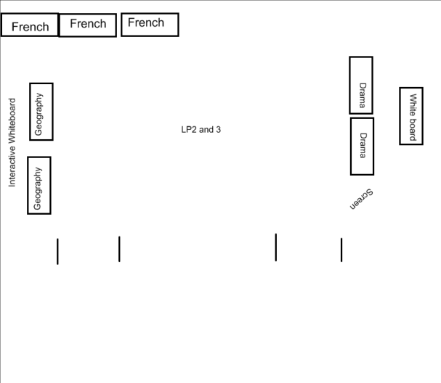
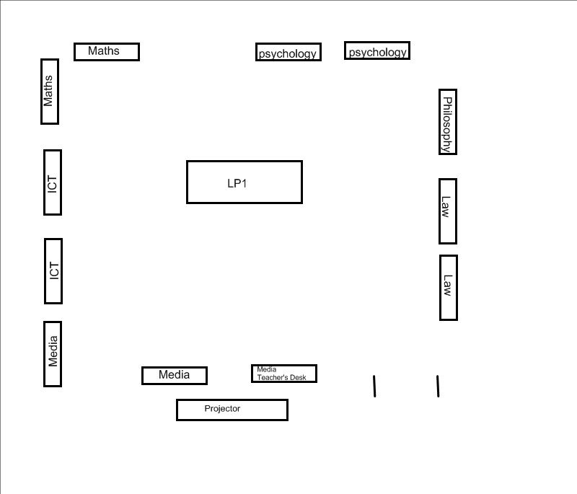
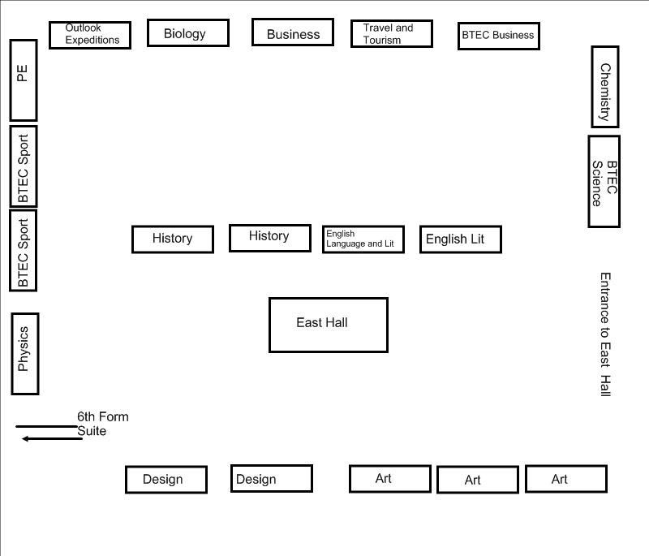

COLLECTIVE ACT OF WORSHIP
Week Beginning
15 November 2010

HUMAN RIGHTS

“Human rights are fundamental to our nature; without them we cannot live as human beings”

(UN Office of Information)

What is meant by Human Rights”

Why can we not live without Human Rights?

“Children should have a right to an education”

(Declaration of Children’s Rights) (UN)

Why is education so important?

Find out about the United Nations Declaration of Human Rights.

“Each individual is truly a person with a nature that is endowed with intelligence and free will, and rights and duties are universal and inviolable”

(Pope John XXIII)

What rights do you think we should have as human beings?

Why is it especially important to ensure that children’s rights are not abused?

DETENTIONS RECORD
 | SURNAME | FORENAME | G | TG | REASON | ISSUED BY | DATE
Yr 7 | Wood | Ryan | M | 10A | 2 x lates | CFa | 09-Nov
 | Beadle | Matthew | M | 10B | Missing 3 homeworks | SCa | 09-Nov
 | Pattison | Kallum | M | 10H | Missed lunchtime detention for missing 3 h/w's - now after school 30 mins | CFa | 12-Nov
Yr 8 | Hurlock | Liam | M | 09B | Missed several detentions 18/10 - 20/10 | MGr | 08-Nov
 | Nikolaev | Bobby | M | 09H | No homework. Did not attend lunch detention | PLe | 11-Nov
 | Lawrence | Callum | M | 09M | Lack of homework. Did not attend lunch detention | PLe | 10-Nov
Yr 9 | Grothier | Jacob | M | 08A | Missed detention 2/11 | MGr | 08-Nov
 | McGonnell | Tori | F | 08A | 4 x late to registration last week | PMw | 11-Nov
 | Prater | Brendan | M | 08A | Not following simple instructions (move seat) | Max Blake | 08-Nov
 | Prater | Brendan | M | 08A | Rude behaviour | JPa | 11-Nov
 | Randall | Albert | M | 08B | 6 x late to registration last week | PMw | 11-Nov
 | Randall | Albert | M | 08B | Rude, argumentative, disruptive | JPa | 11-Nov
 | Bird | Bobby | M | 08C | Re-set from 3/11 - 1 hour | MHy | 12-Nov
 | Hilton-Smith | Melody | F | 08C | 3 x late to registration last week | PMw | 11-Nov
 | Skeggs | Daniel | M | 08E | Re-set from 4/11/10 | MHy | 11-Nov
 | Skeggs | Daniel | M | 08E | Repeatedly shouting out in class | AFl | 11-Nov
 | Beadle | Nicholas | M | 08H | Missed several detentions | MGr | 08-Nov
 | Jocelyn | Sophie | F | 08H | Talking over form teacher, asked to come back at lunch and Sophie did not arrive | CBe | 08-Nov
 | Chamberlain | Charley | F | 08M | Yellow uniform card issued | GTh | 08-Nov
 | George | Matthew | M | 08M | 2 x lates | RHu | 09-Nov
 | Harris | Joe | M | 08M | Detention for maths for repeatedly forgetting homework | GTh | 08-Nov
 | Harris | Joe | M | 08M | 3 x late to registration last week | PMw | 11-Nov
 | Parsons | Lily | F | 08M | 4 x late to registration last week | PMw | 11-Nov
 | Tovey | Ross | M | 08M | Yellow uniform card issued | GTh | 08-Nov
 | Tovey | Ross | M | 08M | Rude and disruptive - sent to FDa | MGr | 08-Nov
 | Tovey | Ross | M | 08M | Extremely disruptive was sent out twice. Kicked door and talking over teacher | JSi | 10-Nov
 | Tovey | Ross | M | 08M | 2 x lates | RHu | 09-Nov
 | Galloway | Ailsa | F | 08P | 4 x late to registration last week | PMw | 11-Nov
 | Thatcher | Bradley | M | 08P | Repeatedly shouting out in class despite warning | AFl | 11-Nov
 | Allen | Stephanie | F | 08U | 2 lates this week & not bringing 1 report back to me | GTh | 08-Nov
 | Allen | Stephanie | F | 08U | Missed detention 2/11 | MGr | 08-Nov
 | Allen | Stephanie | F | 08U | 2 lates in a week | PLe | 10-Nov
 | Allnutt | Charmian | F | 08U | 2 lates in a week | PLe | 10-Nov
 | Nuttall | Jordan | M | 08U | Rude and disruptive - sent to FDa | MGr | 08-Nov
 | Popps | Hayden | M | 08U | Walking away when kept at the end of the lesson | MHy | 12-Nov
Yr 10 | Bullman | Max | M | 07B | No maths h/w 9/11 | CBe | 10-Nov
 | Crossley | Rhys | M | 07B | 3 x late to registration last week | DWi | 11-Nov
 | Dean | George | M | 07B | Talking during lesson asked to come back at lunch and he did not arrive | CBe | 08-Nov
 | Chapman | Natasha | F | 07C | 4 x late to registration last week | DWi | 11-Nov
 | Joiner | Laurie | M | 07C | 4 x late to registration last week | DWi | 11-Nov
 | Lambert | Holly | F | 07C | 3 x late to registration last week | DWi | 11-Nov
 | Barratt | Laura | F | 07E | 3 x late to registration last week | DWi | 11-Nov
 | Burns | Reece | M | 07E | 3 x late to registration last week | DWi | 12-Nov
 | McKengo | Divine | F | 07E | 4 x late to registration last week | DWi | 11-Nov
 | Taylor | James | M | 07E | 5 x late to registration last week | DWi | 12-Nov
 | Craig-Lesser | Megan | F | 07H | Rude and disrespectful | SCl | 12-Nov
 | Kippen | Amber | F | 07H | 4 x late to registration last week | DWi | 12-Nov
 | Adams-Robinson | Lavell | M | 07M | 4 x late to registration last week | DWi | 11-Nov
 | Eley | Mitchell | M | 07M | 4 x late to registration last week | DWi | 11-Nov
 | Lipley-Hinton | Renee | F | 07M | 3 x late to registration last week | DWi | 12-Nov
 | Paris | Ben | M | 07M | Failure to follow instructions | VMa | 11-Nov
 | Street-White | Elijah | M | 07M | 5 x late to registration last week | DWi | 12-Nov
 | Finch | Connor | F | 07P | Left the class after a request to stay behind at lunch time | CBe | 11-Nov
 | Pinner | Sam | F | 07P | Failure to follow instructions | VMa | 11-Nov
 | Carter | Josh | M | 07U | No maths h/w 9/11 | CBe | 10-Nov
Yr 11 | Allen | Michael | M | 06A | No Homework despite extension | API | 10-Nov
 | Bait | Dan | M | 06A | No Homework despite extension | API | 10-Nov
 | Bragg | Sam | M | 06A | No Homework despite extension | API | 10-Nov
 | Gyseman | Anthony | M | 06A | Disrupting a test | KKn | 10-Nov
 | Best | Oliver | M | 06B | Disrupting a test | KKn | 10-Nov
 | Best | Oliver | M | 06B | No Homework despite extension | API | 10-Nov
 | Feltham | Matthew | M | 06B | Missed detentions in Maths | CCa | 11-Nov
 | Forbes | Lucy | F | 06B | Has not handed in draft of English c/w essay | SJo | 08-Nov
 | Hersom | Ryan | M | 06B | No Homework despite extension | API | 10-Nov
 | Oakley | Alex | M | 06B | Disrupting a test | KKn | 10-Nov
 | Shephard | Emma | F | 06B | No Homework despite extension | API | 10-Nov
 | Bamfield | Jordan | M | 06C | 3 x late to registration last week | DWi | 11-Nov
 | Bolton | Megan | F | 06C | No Homework despite extension | API | 10-Nov
 | Dipple | Matthew | M | 06C | No Homework despite extension | API | 10-Nov
 | Hall | Robert | M | 06C | No Homework despite extension | API | 10-Nov
 | Lunney | Matthew | M | 06C | No Homework despite extension | API | 10-Nov
 | Pryor | Charlie | M | 06C | No Homework despite extension | API | 10-Nov
 | Pryor | Charlie | M | 06C | Disrupting a test | KKn | 10-Nov
 | Bright | Ruby | F | 06E | No h/w 8/11 | CBe | 10-Nov
 | Cleary | Ryan | M | 06E | No Homework despite extension | API | 10-Nov
 | Parsons | Harry | M | 06E | Missed detentions in Maths | CCa | 11-Nov
 | Phillipe | Tom | M | 06E | No Homework despite extension | API | 10-Nov
 | Sinfield | Dan | M | 06E | No Homework despite extension | API | 10-Nov
 | Thatcher | Jake | M | 06E | Rude to an LSA and swearing in front of staff | ESm | 09-Nov
 | Winnell | James | M | 06E | Failing to return to lesson after a fire drill | KKn | 10-Nov
 | Goddard-Rable | Shannon | F | 06H | No h/w 8/11 | CBe | 10-Nov
 | Lawal | Farooq | M | 06H | Failing to return to lesson after a fire drill | KKn | 10-Nov
 | Lawal | Farooq | M | 06H | Disrupting a test | KKn | 10-Nov
 | Lawal | Farooq | M | 06H | 3 x late to registration last week | DWi | 11-Nov
 | McElvenny | Shannon | F | 06H | No Homework despite extension | API | 10-Nov
 | Nicholls | Charlotte | F | 06H | Poor behaviour in Business Studies Test. Rude Language used in test | MHa | 08-Nov
 | Nicholls | Charlotte | F | 06H | 4 x late to registration last week | DWi | 11-Nov
 | O'Donnell | Hayley | F | 06H | No Homework despite extension | API | 10-Nov
 | Owens | Ellie | F | 06H | No Homework despite extension | API | 10-Nov
 | Vickers | Jodie | F | 06H | 3 x late to registration last week | DWi | 11-Nov
 | Williams | Robert | M | 06H | No Homework despite extension | API | 10-Nov
 | Clark | Samantha | F | 06M | No Homework despite extension | API | 10-Nov
 | Freeman | Misha | F | 06M | Disrupting a test | KKn | 10-Nov
 | O'Brien | Shane | M | 06M | No Homework despite extension | API | 10-Nov
 | Dark | Luca | F | 06P | 3 x late to registration last week | DWi | 11-Nov
 | Fox | Abigail | F | 06P | No Homework despite extension | API | 10-Nov
 | Milton | Harry | M | 06P | No Homework despite extension | API | 10-Nov
 | Mulryne | Stevie | M | 06P | Disrupting a test | KKn | 10-Nov
 | Mulryne | Stevie | M | 06P | 6 x late to registration last week | DWi | 11-Nov
 | Allwood | Jamie | M | 06U | No Homework despite extension | API | 10-Nov
 | Allwood | Jamie | M | 06U | 4 x late to registration last week | DWi | 11-Nov
 | Cook | Stacey | F | 06U | Disrupting a test | KKn | 10-Nov
 | Cook | Stacey | F | 06U | No homework 8/11 | CBe | 10-Nov
 | Fair | Leah | F | 06U | Disrupting a test | KKn | 10-Nov
 | McGonnell | Dee-Louise | F | 06U | Poor behaviour in Business Studies Test. Rude Language used in test | MHa | 08-Nov
 | McGonnell | Dee-Louise | F | 06U | 4 x late to registration last week | DWi | 11-Nov
 | Michaels | Allie | F | 06U | 3 x late to registration last week | DWi | 11-Nov
 | Reddin | Brandon | M | 06U | No Homework despite extension | API | 10-Nov
 | Walter | Adam | M | 06U | No Homework despite extension | API | 10-Nov
 | Welch | Jack | M | 06U | No Homework despite extension | API | 10-Nov

